

**A**

**Project Report**

**On**

# E-Commerce Website

*Submitted*

*In partial fulfilment*

*For the award of the Degree of*

***Bachelor of Technology***

***In Department of Computer Science Engineering***

**IN**

## **G.L.A. University ,Mathura**

Submitted by- Submitted to- Yash Kumar Singh Mr. Sanjay Madaan

Yogesh Chauhan

Akash Rajput

Yatin Sisodia

## *Bonafide Certificate*

Certified that this project report “**E-Commerce Website”**

is the bonafide work of “**Yash Kumar Singh ,Yogesh**

**Chauhan , Akash Rajput ,Yatin Sisodia”** who carried out the

project work under my/our Supervision.

|  |  |
| --- | --- |
| **SIGNATURE**    Dr. Rohit Agrawal  **HEAD OF THE DEPARTMENT**  Computer Science & Application | **SIGNATURE**    Mr.Sanjay Madaan  **SUPERVISOR**  Technical Trainer  Computer Science &Applications |

Submitted for the project viva-voce examination held on -28/11/2023

Chapter 1 : Introduction

E-commerce Website. A website that allows people to buy and sell physical goods, services, and digital products over the internet rather than at a brick-and-mortar location. Through an e-commerce website, a business can process orders, accept payments, manage shipping and logistics, and provide customer service.

# **Client Identification**

 Multi-factor authentication requires that the user uses a user id, password to login in e-commerce by which we identify the the client.

# **Identification of Problem**

* Data Capitalization. ...
* Increased Customer Expectations. ...
* Logistics Issues. ...
* Challenges Associated with Store Agility. ...
* Hosting Issues. ...
* Personalizing Your Ecommerce Store. ...
* Dealing with Competition. ...
* Devising Growth Strategies.

# Identification of Tasks

There are more tasks you can automate, but the seven mentioned – tax compliance, inventory management, payments, customer service, fulfillment, accounting and bookkeeping, and returns.

# **Organisation Of the Report**

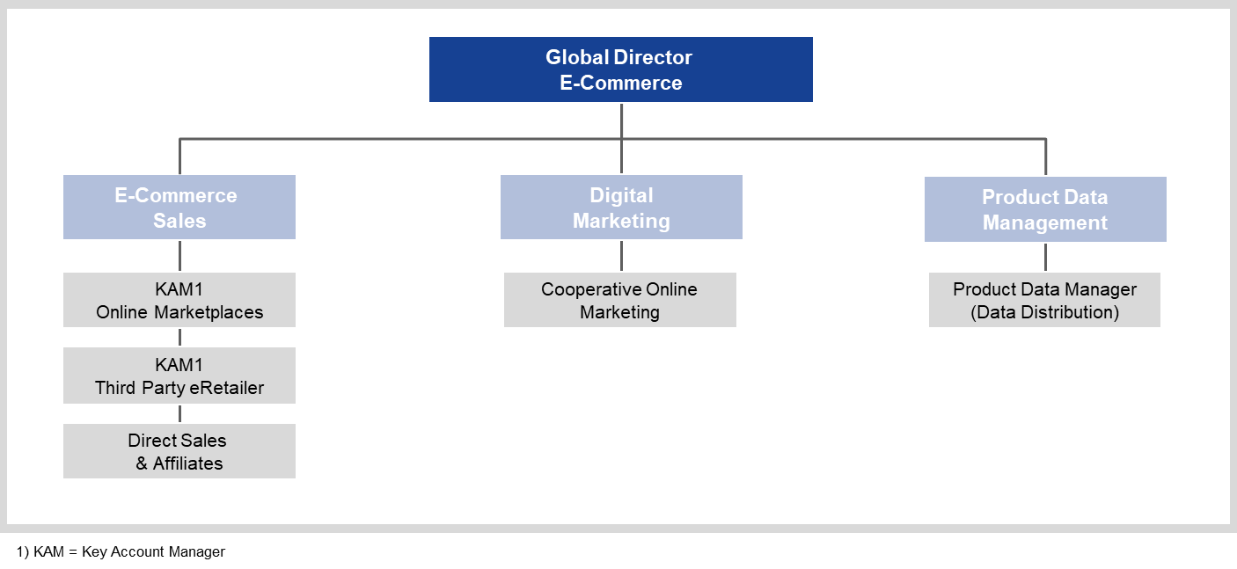

* **E-Commerce sales:** Depending on the E-Commerce distribution strategy, the roles of different channel-specific key account managers can be combined.  Further dedicated sub-organisations may exists depending on the size of the individual channels (e.g. an Amazon unit with vendor account management).
* **Digital marketing:**Central coordination of online marketing activities. This foundation may be modified slightly for specific channels, but does not deviate significantly from a set of key tasks.
* **Product data management:**As an interface between product management and marketing, this section is responsible for the central provision and administration of product data required for various online channels.

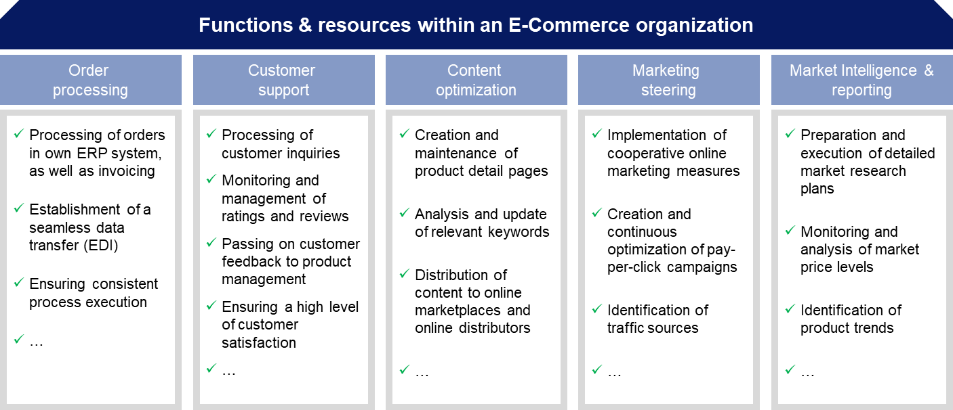

Chapter 2: Review/Background Study

# **2.1. Timeline of the Reported problem**

eCommerce started approximately 40 years ago as a standard exchange of business documents such as orders or invoices from suppliers and business customers. Back then, many industries elaborated upon a system that pertained to the interchanging data between one computer to another, and that’s how eCommerce was born.

The history of eCommerce is closely related to the history of the internet, and online shopping only became possible when the internet was opened to the public in 1991. Electronic Data Interchange (EDI) and teleshopping in the 1970s created a way for the modern-day eCommerce store as we know it today. Also, Amazon was one of the first eCommerce websites to start selling products in the US, and then the idea was copied by many businesses.

However, the convenience, safety, and user experience of online shopping have improved, and businesses are striving to do so even today.

# 

# **2.2. Proposed Solutions**

* Consider an e-commerce platform. ...
* Design for a target audience and brand identity. ...
* Build a marketing strategy. ...
* Offer a mobile option. ...
* Create a loyalty program. ...
* Offer a detailed catlog and competitive prices. ...
* Personalize the shopping experience. ...
* Adequately staff a contact center.

# 2.3. Bibliometric analysis

Online Shopping is increasingly becoming popular across the globe. This is relatively a new area of research, which gained significant growth and attention in last decade. This study conducts a bibliometric analysis of the “Online Shopping” research area by collecting research papers and data from Web of Science (WOS) for the period of 2000 to 2014. A total of 772 papers with 7,313 citations from WOS were found. Based on these papers and citations, it evaluates the research performance of journals, authors, and papers related to “Online Shopping” research area on the three evaluation criteria of productivity, sustainability, and impact. It was found from the analyses that Journal of Business Research, Marketing Science, Information & Management, and Psychology & Marketing are the top journals from all the three evaluation criteria of productivity, sustainability, and impact. However, research publications on Online Shopping or e-Commerce are fragmented and depending on the content and author’s preference, researches get published in various journals, sometimes related to Technology, Marketing, Operations, or Management area. Benbasat, Izak was the top author from productivity and sustainability perspective. He wrote 10 papers in 7 different years in the period 2000 to 2014. However, the highest cited paper had 995 citations, written by Gefen, D et al in 2003.

# 2.4. Review Summary

An e-commerce website is one that allows people to buy and sell physical goods, services, and digital products over the internet rather than at a brick-and-mortar location. Through an e-commerce website, a business can process orders, accept payments, manage shipping and logistics, and provide customer service.

# **2.5. Problem Definition**

Our e-commerce website is enable to login, register, add products to the cart, payment at the time of delivery, user can filter the products at the time of shopping by categories and by prices.

This is done by using HTML, CSS, NodeJS, Bootstrap, Express, MongoDB, React. The interface is designed by using Bootstrap, html and CSS. The user data is stored in the Database by using MongoDB. The searching and sorting is done by using NodeJS and react. The login, register is also done by using the NodeJS.

There are some features which is not added yet are – product tracking ,Return , replacement, customer support etc.

# **2.6. Goals And Objectives**

# **Objectives**

* eCommerce websites allow retailers to **sell products** online, and enable consumers to browse, evaluate, and purchase products from the comfort of their home.
* eCommerce website allow the consumers to buy product from anywhere e.g. from home , office, college etc.
* People can do payment at the time of delivery after ensure the product is correct or not.
* Our main objective is to increase the flexibility of the consumers.

# **Goals**

* Increasing traffic from social media.
* Getting more leads from SEO.
* Creating more compelling content.
* Better use of email marketing.
* Improved shopping cart abandonment rates.
* Increased conversion rates.
* Increased customer satisfaction.

Chapter 3: Design Flow / Process

# 3.1. Evaluation & Selection Of Specifications/Features

* Content management capabilities.
* Promotion & discount code tools.
* An easy-to-use checkout.
* SEO friendly code and layout.
* Easily add product to cart to buy in future.
* Admin can add and delete product.
* Admin can track the activity of the user/consumer on the site.

# 3.2. Design Constraint

* Making the Consumer Trust Your Website.
* Ensuring a Hassle-Free Payment System.
* Keeping Track Of Your Stock.
* Making Sure that the Products look Visually Appealing.
* Utilization of Image Alt Text.
* SEO Optimization to Generate Traffic.
* Ensure that Onsite Search Engine is Smoothly Running.

# 3.3. Design Flow

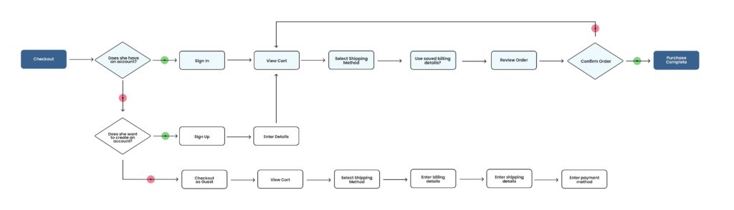

# 3.4. METHODOLOGY

eCommerce implementation consists of all the steps related to the launch, update, and maintenance of an online store. eCommerce allows businesses to sell products from anywhere at any time, and it connects businesses to new customers who were previously unreachable due to distance and hours of operation.

* HTML
* CSS
* Bootstrap
* NodeJS
* Express
* MongoDB
* React

**UI DEVELOPMENT**

Technologies that are mostly used to develop a user interface are:-

* HTML
* CSS
* Bootstrap

**3.4.1 HTML**

HTML stands for Hyper Text Markup Language. HTML is the standard markup language for creating Web pages. HTML describes the structure of a Web page. HTML consists of a series of elements. HTML elements tell the browser how to display the content.

* HTML stands for Hyper Text Markup Language
* HTML is the standard markup language for creating Web pages
* HTML describes the structure of a Web page
* HTML consists of a series of elements
* HTML elements tell the browser how to display the content

**A** simple HTML syntax:-

<!DOCTYPE html>  
<html>  
<head>  
<title>Page Title</title>  
</head>  
<body>  
  
<h1>My First Heading</h1>  
<p>My first paragraph.</p>  
  
</body>  
</html>

**3.4.2 CSS**

CSS stands for Cascading Style Sheets. CSS describes how HTML elements are to be displayed on screen, paper, or in other media. CSS saves a lot of work. It can control the layout of multiple web pages all at once.CSS is used to define styles for your web pages, including the design, layout and variations in display for different devices and screen sizes.

A basic syntax of CSS:-

body {  
  background-color: lightblue;  
}  
  
h1 {  
  color: white;  
  text-align: center;  
}  
  
p {  
  font-family: verdana;  
  font-size: 20px;  
}

**3.4.3 Bootstrap**

* Bootstrap is the most popular HTML, CSS and JavaScript framework for developing a responsive and mobile friendly website.
* It is absolutely free to download and use.
* It is a front-end framework used for easier and faster web development.
* It includes HTML and CSS based design templates for typography, forms, buttons, tables, navigation, modals, image carousels and many others.
* It can also use JavaScript plug-ins.
* It facilitates you to create responsive designs.

Following are the main advantage of Bootstrap:

* It is very easy to use. Anybody having basic knowledge of HTML and CSS can use Bootstrap.
* It facilitates users to develop a responsive website.
* It is compatible on most of browsers like Chrome, Firefox, Internet Explorer, Safari and Opera etc.

### **Bootstrap package contains**

**Scaffolding:** Bootstrap provides a basic structure with Grid System, link styles, and background.

**CSS:** Bootstrap comes with the feature of global CSS settings, fundamental HTML elements style and an advanced grid system.

**Components:** Bootstrap contains a lot of reusable components built to provide iconography, dropdowns, navigation, alerts, pop-overs, and much more.

**JavaScript Plugins:** Bootstrap also contains a lot of custom jQuery plugins. You can easily include them all, or one by one.

**Customize:** Bootstrap components are customizable and you can customize Bootstrap's components, LESS variables, and jQuery plugins to get your own style.

**Scripting**

There are two scripting methodologies.

* 1. Server side Scripting: This scripting is done at the server end.
  2. Client side scripting : This scripting is done at the client end or the browser.

***Scripting Languages***

**The languages are used for scripting are :-**

1. NodeJS
2. React
3. Express
4. MongoDB(for database)

**NodeJS**

As an asynchronous event-driven JavaScript runtime, Node.js is designed to build scalable network applications. In the following "hello world" example, many connections can be handled concurrently. Upon each connection, the callback is fired, but if there is no work to be done, Node.js will sleep.Node.js is similar in design to, and influenced by, systems like Ruby's [Event Machine](https://github.com/eventmachine/eventmachine) and Python's [Twisted](https://twistedmatrix.com/trac/). Node.js takes the event model a bit further. It presents an event loop as a runtime construct instead of as a library. In other systems, there is always a blocking call to start the event-loop. Typically, behavior is defined through callbacks at the beginning of a script, and at the end a server is started through a blocking call like . In Node.js, there is no such start-the-event-loop call. Node.js simply enters the event loop after executing the input script. Node.js exits the event loop when there are no more callbacks to perform. This behavior is like browser JavaScript — the event loop is hidden from the user.Node.js being designed without threads doesn't mean you can't take advantage of multiple cores in your environment. Node.js being designed without threads doesn't mean you can't take advantage of multiple cores in your environment. Child processes can be spawned by using our  API, and are designed to be easy to communicate with. Built upon that same interface is the [cluster](https://nodejs.org/api/cluster.html) module, which allows you to share sockets between processes to enable load balancing over your cores.

**React**

React provides state-of-the-art functionality and is an excellent choice for developers looking for an easy-to-use and highly productive JavaScript framework. Using React, you can build complex UI interactions that communicate with the server in record time with JavaScript-driven pages.

React is a good fit for projects with multiple state changes that are intertwined and dependent on each other. Changes are tracked on the virtual DOM and then applied to the real DOM, ensuring that React uses the virtual DOM to keep track of changes in the application, then updates the real DOM with those changes.

**Express**

Express is a fast, assertive, essential and moderate web framework of Node.js. You can assume express as a layer built on the top of the Node.js that helps manage a server and routes. It provides a robust set of features to develop web and mobile applications

Let's see some of the core features of Express framework:

* It can be used to design single-page, multi-page and hybrid web applications.
* It allows to setup middlewares to respond to HTTP Requests.
* It defines a routing table which is used to perform different actions based on HTTP method and URL.
* It allows to dynamically render HTML Pages based on passing arguments to templates.

## **Why use Express**

* Ultra fast I/O
* Asynchronous and single threaded
* MVC like structure
* Robust API makes routing easy

**MongoDB**

[MongoDB](https://www.javatpoint.com/mongodb-tutorial) is an open-source document database that provides high performance, high availability, and automatic scaling.

In simple words, you can say that - Mongo DB is a document-oriented database. It is an open source product, developed and supported by a company named 10gen.

MongoDB is available under General Public license for free, and it is also available under Commercial license from the manufacturer.

The manufacturing company 10gen has defined MongoDB as:

"MongoDB is a scalable, open source, high performance, document-oriented database." - 10gen

MongoDB was designed to work with commodity servers. Now it is used by the company of all sizes, across all industry.

**Feature of MongoDB**

**1. Support ad hoc queries**

In MongoDB, you can search by field, range query and it also supports regular expression searches.

**2. Indexing**

You can index any field in a document.

**3. Replication**

MongoDB supports Master Slave replication.

A master can perform Reads and Writes and a Slave copies data from the master and can only be used for reads or back up (not writes)

**4. Duplication of data**

MongoDB can run over multiple servers. The data is duplicated to keep the system up and also keep its running condition in case of hardware failure.

**5. Load balancing**

It has an automatic load balancing configuration because of data placed in shards.

**6. Supports map reduce and aggregation tools**.

**7. Uses [JavaScript](https://www.javatpoint.com/javascript-tutorial) instead of Procedures**.

**8. It is a schema-less database written in [C++](https://www.javatpoint.com/cpp-tutorial)**.

**9. Provides high performance**.

**10. Stores files of any size easily without complicating your stack**.

**11. Easy to administer in the case of failures**.

**12. It also supports:**

* JSON data model with dynamic schemas
* Auto-sharding for horizontal scalability
* Built in replication for high availability
* Now a day many companies using MongoDB to create new types of applications, improve performance and availability.

**Packages used :-**

**JSON**

JSON is a syntax for serializing objects, arrays, numbers, strings, booleans, and null . It is based upon JavaScript syntax, but is distinct from JavaScript: most of JavaScript is not JSON. For example: Objects and Arrays.

**AXIOS**

Axios: Axios is a Javascript library used to make HTTP requests from node. js or XMLHttpRequests from the browser and it supports the Promise API that is native to JS ES6. It can be used intercept HTTP requests and responses and enables client-side protection against XSRF. It also has the ability to cancel requests.

**Toast**

React toasts are lightweight notifications designed to mimic the push notifications that have been popularized by mobile and desktop operating systems. They're built with flexbox, so they're easy to align and position.

**Spinner**

Bootstrap “spinners” can be used to show the loading state in your projects. They're built only with HTML and CSS, meaning you don't need any JavaScript to create them. You will, however, need some custom JavaScript to toggle their visibility.

**Screenshots Of the features of our eCommerce Website**

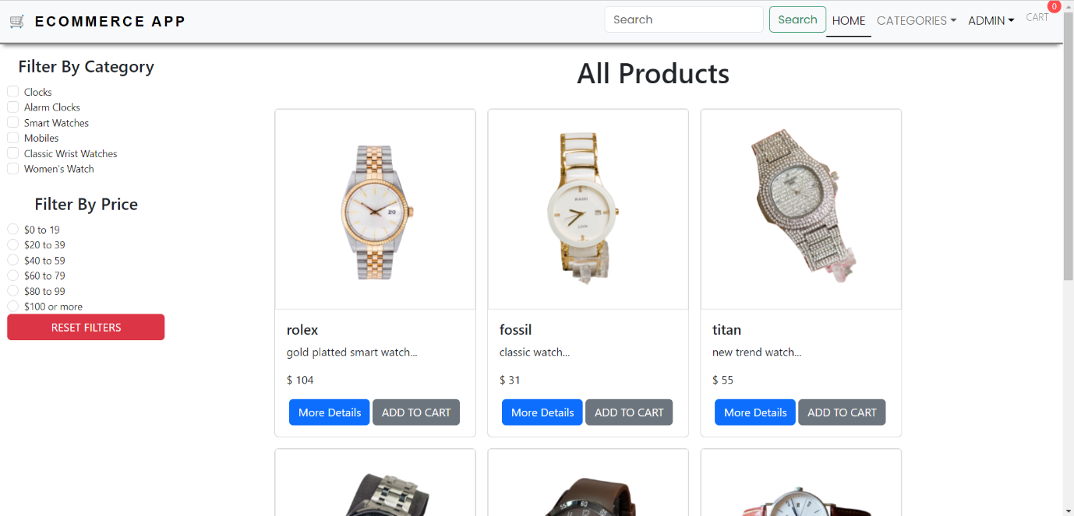**Home**

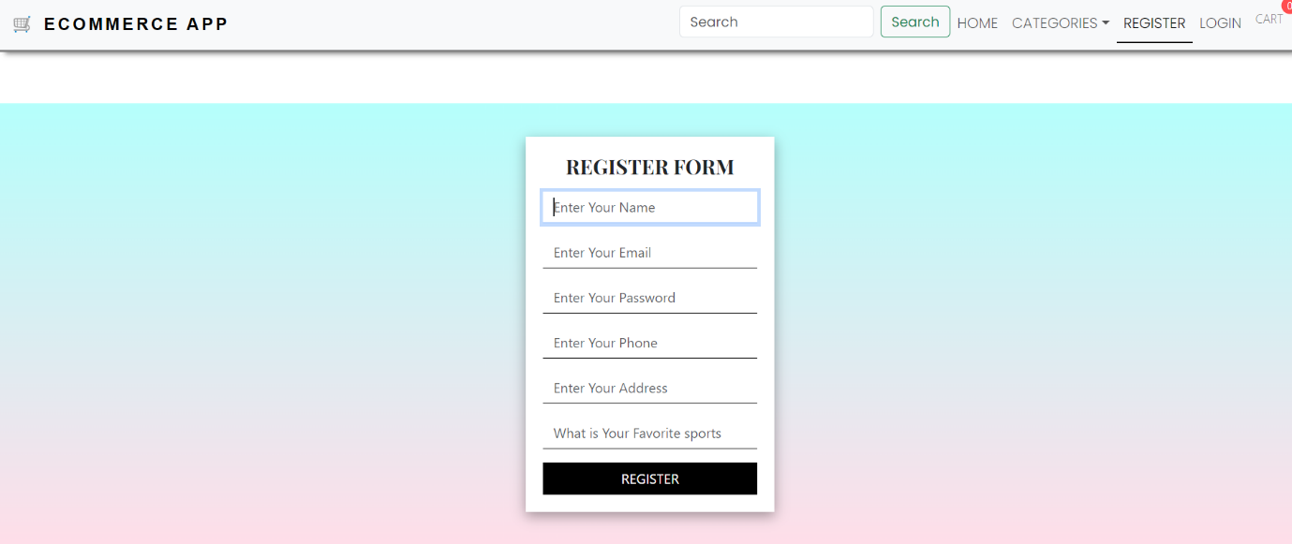**Register**

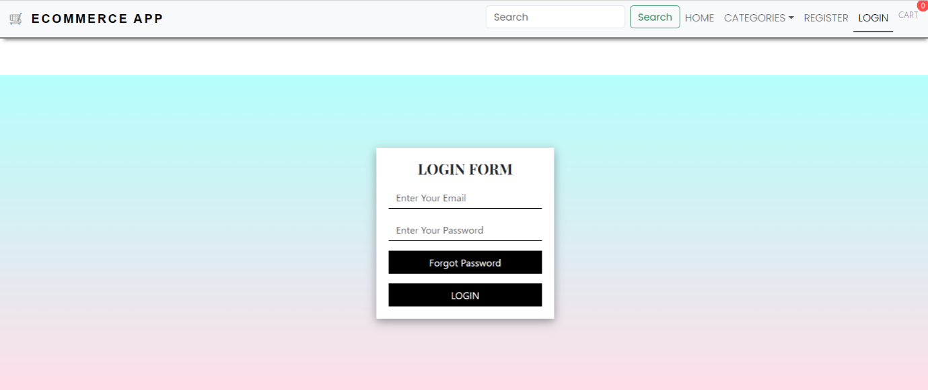 **Login**

**Filter by category and Price**

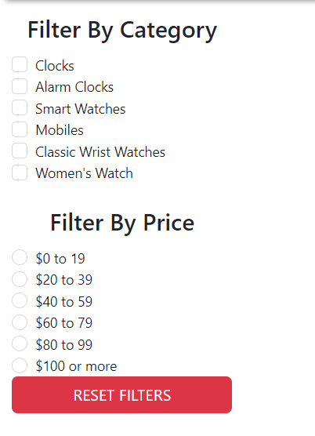

**CART**

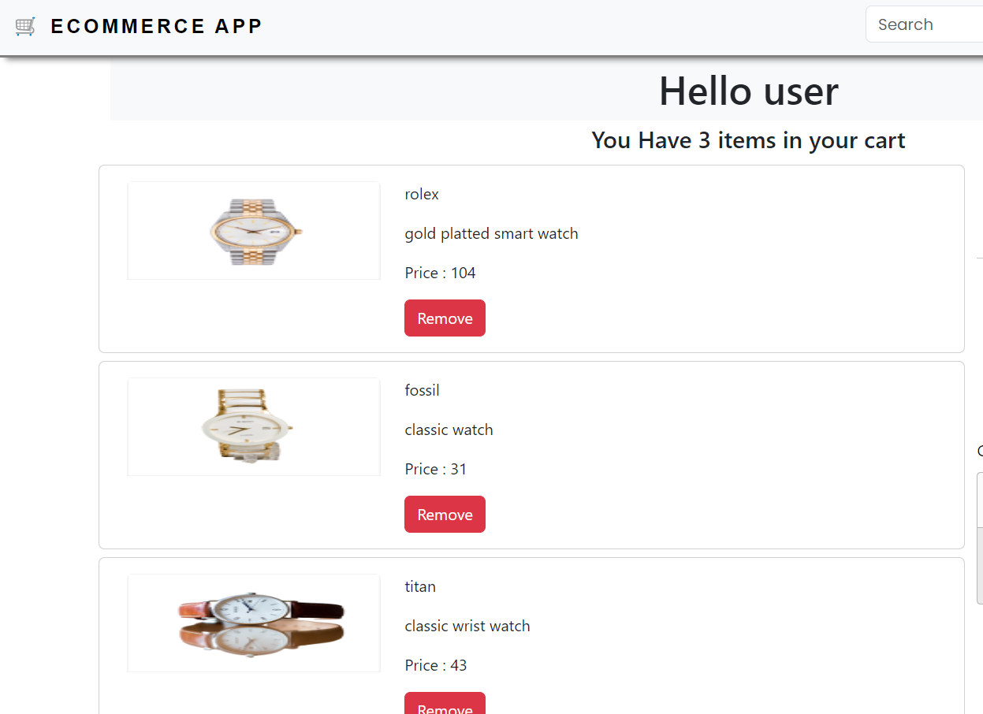

**Payment**

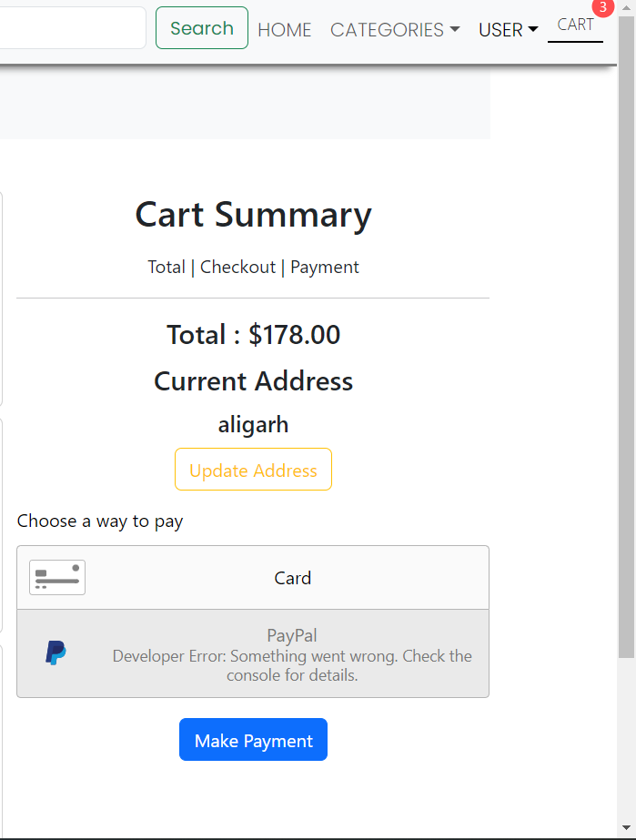

**Future work And Enhancement**

* 1. E-Commerce would help each and every person to buy and sell products via our website and get is at home it will save their time.
  2. It would provide huge collection of products in future.
  3. We will add more products of basic uses .
  4. We will enhance our site by adding product tracking .
  5. We will also add customer support.
  6. We will enhance by adding refund and replacement in our site.

**CONCLUSION**

We have successfully implemented the site ‘E-Commerce’. With the help of various links and tools, we have been able to provide a site which will be live soon and running on the web. We have been successful in our attempt to take care of the needs of both the user as well as administrator. Finally we hope that this will go a long way in popularizing.

**Reference**

* 1. **[www.javatutpoint.com](http://www.javatutpoint.com)**
  2. **[www.w3schools.com](http://www.w3schools.com)**
  3. **Wikipedia**
  4. **<https://youtu.be/A_-fn_ij59c?si=CZaQHvgx4gSS6R6M>**